Lesson Plan: Electrical Symbols (age 11 – 14) –
Making Circuits from Circuit Diagrams

Objectives:

The aim of this experiment is introduce circuit diagrams and electrical circuit symbols and learn to read simple circuit diagrams to construct electric circuits.

Lesson introduction (15 min):

Recap on previous learning on electric current, simple circuits and symbols. Can link to student revision notes on www.twothirtyvolts.org to access a list of electric circuit symbols. Set students the Electrical Symbol Quiz to complete on www.twothirtyvolts.org . Explain experiment and learning objectives.

Lesson activity (30 min):

Group students in pairs and task them to:
- Draw and construct each of the following circuits.
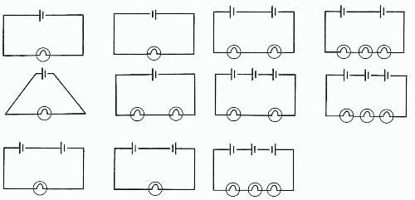
- Record on the Worksheet the observations of the operation of the circuits.

Lesson demonstration (10 min):

Select some of the students to inform the rest of the class about their findings.

Lesson review (5 min):

Recap on learning regarding symbols from Quiz and from experiment and establish levels of understanding.

Resources required:

The following resources are required per pair of students: Circuit board; Bulbs (3); Batteries (3); & Leads. Access to internet for www.twothirtyvolts.org

Expected Outcomes:

By the end of the session students will understand the main electric circuit symbols and construct physical electrical circuits from circuit diagrams.
Student sheet: Electrical Symbols –
Making Circuits from Circuit Diagrams.

Objectives:

By the end of the session you will understand the main electric circuit symbols and construct physical electrical circuits from circuit diagrams.

Resources required:

The following resources are required per pair of students: Circuit board; Bulbs (3); Batteries (3); & Leads. Access to internet for www.twothirtyvolts.org

Introduction:

Access and undertake Student Quiz on Electrical Symbols at www.twothirtyvolts.org

Activity:

Working in pairs undertake the following tasks:

- Copy the first circuit diagram onto the Worksheet, construct the circuit with the equipment provided, and then record on the Worksheet next to the draw circuit diagram what you observe. Repeat for each circuit in turn.

Further work:

- Review notes and quiz on electrical circuits at www.Twothirtyvolts.org:

Linked Resources

www.twothirtyvolts.org:

Electrical Symbols 11-14 Student Revision Notes
Electrical Symbols 11-14 Revision Quiz
Worksheet: Electrical Symbols – Making Circuits from Circuit Diagrams.

Circuit | Observation

