Student sheet: Electrical Symbols –
Making Circuits from Circuit Diagrams.

Objectives:

By the end of the session you will understand the main electric circuit symbols and construct physical electrical circuits from circuit diagrams.

Resources required:

The following resources are required per pair of students: Circuit board; Bulbs (3); Batteries (3); & Leads. Access to internet for www.twothirtyvolts.org

Introduction:

Access and undertake Student Quiz on Electrical Symbols at www.twothirtyvolts.org

Activity:

Working in pairs undertake the following tasks:

- Copy the first circuit diagram onto the Worksheet, construct the circuit with the equipment provided, and then record on the Worksheet next to the draw circuit diagram what you observe. Repeat for each circuit in turn.
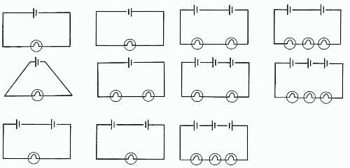

Further work:

- Review notes and quiz on electrical circuits at www.twothirtyvolts.org:

Linked Resources

www.twothirtyvolts.org:

Electrical Symbols 11-14 Student Revision Notes
Electrical Symbols 11-14 Revision Quiz
Worksheet: Electrical Symbols – Making Circuits from Circuit Diagrams.

Circuit | Observation

